MIDTERM ACTIVITY 2: ANALYZE THE FLOWCHART ALGORITHM
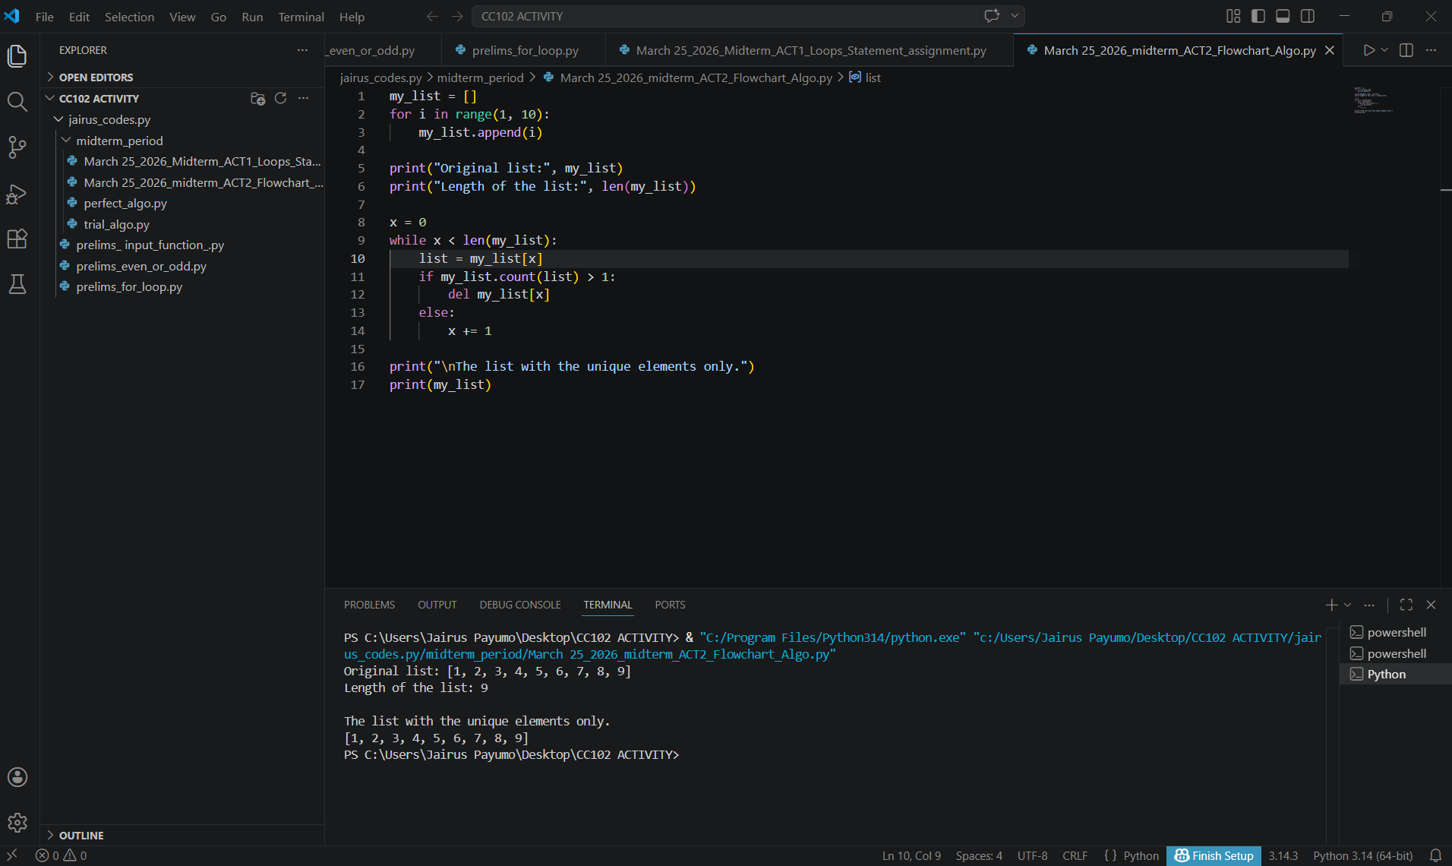

LINE BY LINE EXPLANATION:

L1. my_list = [] - This code creates an empty list.
L2. for i in range(1, 10): - This code starts a loop where the (i) variable goes from 1 to 9.
L3. my_list.append(i) - This code adds the current number (i) variable to my_list.
L5. print("Original list:", my_list) - This code shows the list before changing it.
L6. print("Length of the list:", len(my_list)) - This code shows how many items are in the list.
L8. x = 0 - This code is the start index x at 0
L9. while x < len(my_list): - This code shows a loop while x is inside the list.
L11 item = my_list[x]: - This code gets the current item using index x.
L11. if my_list.count(my_list[x]) > 1: - This code checks if the current item appears more than once in the list.
L12. del my_list[x] - If it does appear more than once, delete it from the list.
L13-L14. else:
x += 1 – This code If no, move to the next item.
L16. print("The list with the unique elements only.") – This code shows a message before printing the final list.
L17. print(my_list) print(my_list) - This code shows the list after removing duplicates.

